Session Chairs Guide
Oona Schmid, Executive Director
Updated information added in red on April 5, 2024

The SAA Board and I are deeply committed to finding the proper balance between keeping the meeting as affordable as possible (which is one aspect of access) and providing the community with digital options (which is a different facet of accessibility). Thus, in 2024, the board authorized the most expansive of three virtual component pilots. We would really appreciate hearing your response to the 2024 effort, as this is an experiment to find out what is most viable for future meetings.
- On the virtual components site, each session has a green “submit session survey” button that takes you to a quick place to provide immediate feedback about the virtual components and how they worked for a specific session.
- On Monday, April 22, I will email meeting registrants a longer post-meeting evaluation about all aspects of the meeting, including the virtual components.

Program participants in symposia, general sessions, forums, lightning rounds, and electronic symposia may present remotely as long as the session chair or their delegate is in the session room in New Orleans and supports these components. Meeting registrants have access to any live streams of these symposia, general sessions, forums, lightning rounds, and electronic symposia.
To support these virtual components, session chairs of symposia, general sessions, forums, lightning rounds, and electronic symposia are asked to take on different responsibilities from prior years. The guide explains the following in more detail:
- collect all session presentations onto a flash drive; name presentation files sequentially on the flash drive (e.g., 01.ppt; 02.ppt);
- bring the flash drive to the session room in New Orleans and insert it into the session laptop;
- introduce speakers and open the slide decks at the podium before each presenter (this includes the virtual presenter[s]);
- in the case of virtual presenters, when you open the slide deck at the podium, you also enable “slide control” so that a remote presenter can advance the slides while presenting;
- repeat comments from the in-room session-room floor and/or from Zoom out loud into the session-room laptop;
- keep time for presenters and cue them to keep the session on schedule.

This guide uses the term “presenters” and “chairs.” Presenters are program participants, and they include discussants, moderators, chairs, and organizers. Coauthors are not “presenters.” Chairs are session organizers, co-organizers, chairs, and co-chairs.
Sessions are broadcast live and are not recorded.

Do ahead
- Contact all your session participants.
  - If you plan to support virtual presenters, ask if any presenter(s) hope to present remotely so you know ahead of time. If you do not plan to support virtual presenters, you may wish to tell all your participants that as well. Regardless you need to collect all presentations and bring on a flashdrive (see Step 2 next.)
  - On March 27, you should have received an email with your program participants to facilitate communication. This list was current on February 1, so confirm that people are still planning to present.
  - At the in-person meeting, a coauthor can present if they are registered for the meeting. This is not true online. Virtual presenters are identified by the virtual components software to be on camera and on mic. Virtual attendees (including coauthors) are not on camera or mic and have no means to present.
  - Remind program presenters of the date and time of the session. Sessions are broadcast live at the times printed in the final program, which follows US Central Time.
  - Direct any virtual presenters to the “Virtual Presenter Guide” at https://saa.org/annual-meeting/virtual-components-pilot and read this guide (for session chairs) very carefully.

- Collect all slides in advance of the meeting.
- Collect slides from all presenters, including those who are in person and who plan to present remotely (if any).
- Name files sequentially—e.g., “01.ppt,” “02.ppt,” etc.—so you can easily find the next presenter’s slides while at the podium.
- Copy all presentations onto a flash drive, which you will bring to the Marriott session room in New Orleans.
- If session has discussant(s), provide materials to the discussant(s).
- In Tip 1 (see below) you may want a backup recording of virtual presentations.
- In Tip 2 (see below) you may want to copy presentations into the cloud, such as Google Drive or Dropbox, in case you lose your flash drive.

- View the “Tips and Tricks for Session Chairs” recording.
  - Recording is available at: https://muse.ai/v/CvrWXg8
  - The session includes a lot of important information if you are planning to support a virtual presenter.

- Test opening the slides from the flashdrive in the speaker ready room in the Marriott hotel
  - Speaker ready room is open on Wednesday from 12:00 p.m. to 10:00 p.m., on Thursday from 6:00 a.m. to 11:00 p.m., and on Friday and Saturday from 6:00 a.m. to 5:00 p.m
  - Open slides from your flashdrive and play in “Slide Show” mode. Go to “slide show” menu and click “From Beginning.”
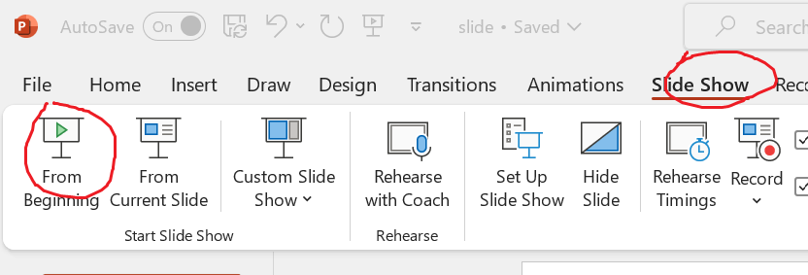

Do at time of session in Marriott session room
- Bring flash drive to in-person session room and insert into session-room laptop in New Orleans
  - Rooms are posted in the final program.
- Do not unplug or shut down your session-room computer(s). Each Marriott session room in New Orleans will have at least one laptop that is hardwired to the ethernet, projector, and the sound system.
- The session room laptop already has the session Zoom broadcasting from the podium, so you are live while you are at the podium. In the case of forums, lightning rounds, and electronic symposia, the session room has a robocam, so discussants are on camera and on mic and you are live while you are at the head table.
- If you bring a laptop (and not a flash drive), do not unplug or shut down the session-room laptop, which is hardwired to session-room projector, sound system, ethernet, and Zoom. Marriott session rooms have volunteer room attendants, and each has been assigned an SAA flash drive. Session-room attendants can be identified by a “volunteer” pin on their badge to help you copy presentations onto the session-room laptop.

- Introduce the session and each speaker
  - At the podium or in a session-room mic and laptop, introduce the first speaker; open the first presenter’s slides and share the slides in the Zoom (already open on session-room laptop.)
  - Each in-room session presenter comes to the podium, give comments, and advance their slides on the session-room laptop.
  - Introducing and opening the next slide deck will be easier if you enumerated file names (e.g., 01.ppt, 02.ppt, etc.) on your flash drive.
  - After each presenter, come up to podium, introduce next presenter, and open their slides and share them in the Zoom (already open on the session-room laptop.)
  - In the case of virtual presenters, you will similarly open the slidedeck at the session-room laptop at the podium. You should open the slides in “Slide show” mode.
  - In the case of virtual presenters, you will similarly share the slidedeck in Zoom (which is already open on the session-room laptop). You need to share the powerpoint window.
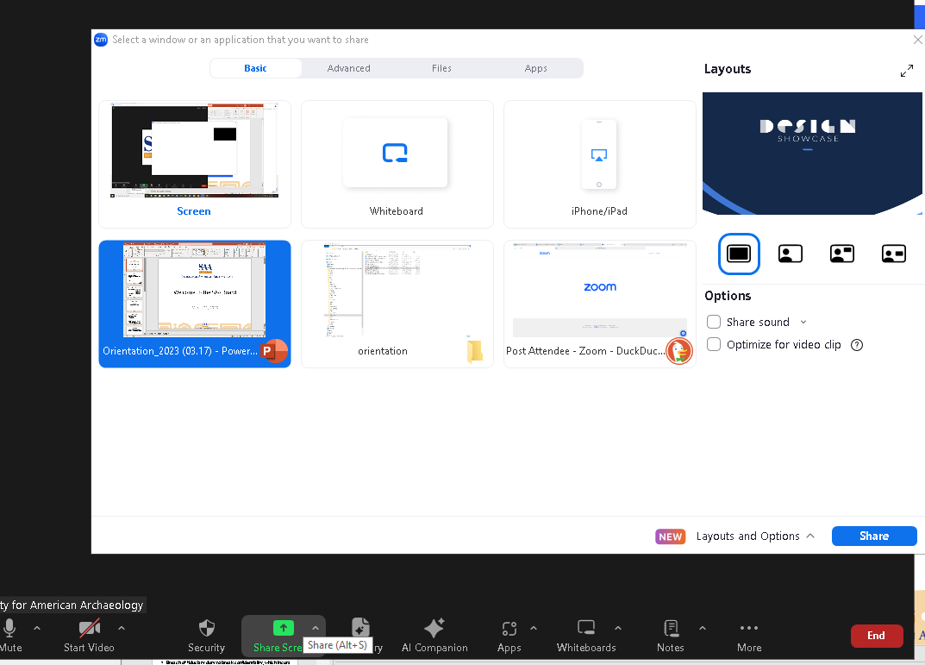
  - In the case of virtual presenters, after you open and share the slide deck, you then enable “slide control” so that a remote presenter can advance the slides while presenting.
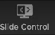
  - When the remote presenter is finished, they return “slide control” to you.
  - To watch a video of how “slide control” works, see https://somup.com/cZnuqlpCCv.

- About Q&A and Discussion
3a. Symposia Q&A
  - In symposia with Q&A slots, session chairs may review the Zoom Q&A for questions that are submitted by the virtual attendees. These Q&A will be on the session-room laptop in the Zoom window.
  - Virtual attendees are not on camera or on mic, so they submit questions using the Zoom Q&A function. Any Q&A will be identified by attendee’s registered name.
  - In symposia, during any Q&A segment, session chairs should repeat questions from the in-person session-room floor and questions from the Zoom Q&A into the mic at the podium, so that everyone knows the question that was asked.
  - The podium mic is a wireless mic, to help make it easier for individuals answering questions to speak into the podium mic, so that all attendees can hear the answer. Alternatively, speakers can go to the podium mic to answer questions. See Tip 4.
  - Session chairs may want to alternate between repeating and responding to in-person and online questions.
3b. Forum / Lightning Round / Electronic Symposia Zoom Q&A and Chat
  - In forums, lightning rounds, and electronic symposia, session presenters may review the Zoom Q&A and Zoom Chat for comments from the virtual audience.
  - Questions and comments from the in-person session-room floor and questions from the Zoom Q&A or Zoom Chat all need to be repeated by a session-room discussant, so that everyone knows the comment or question under discussion.
  - Session presenters may want to mute their mics until they are speaking.
  - Session chairs may want to alternate between repeating and responding to in-person and online attendees.
  - Virtual attendees are not on camera or on mic, so they participate by Zoom Chat and Zoom Q&A function. Any Zoom Q&A or Zoom Chat comments will be identified by attendee’s registered name.
  - All meeting registrants agreed to adhere to the SAA’s Code of Conduct when registering for the meeting. SAA meeting registrants are paying for a third-party vendor to staff forums, lightning rounds, and electronic symposia. This third-party vendor has been instructed that the SAA will not tolerate the following behavior and can remove from the session Zoom a virtual attendee whose comments include
    - Any profanity
    - Any comments about another individual’s religion, skin color, body type, sexual orientation, racial or ethnic background, political orientation, gender identity, and/or age (i.e., ad hominem attacks)
    - Disparaging comments repeatedly directed at a single individual (e.g., bullying)
  - If anyone believes a violation of the SAA Code of Conduct has occurred, please email screenshots to the SAA President (president@saa.org) and/or Executive Director (saaannualmeeting@gmail.com) for a formal review. You are also welcome to contact the SAA ombuds at saaombuds@gmail.com or +1 (949) 293-7515.

- Keep session on time
  - Keep your session on time by cuing presenters when they are running low on time.
  - Bring a cue card that you can hold up (wave) as speakers get close to the end of their time.
  - Ask virtual presenters to set a timer so that they are aware when 15 minutes is over.
  - Session chairs can politely prompt at the podium that the session room likely has another session using the room and so the session needs to stay on time.
  - Make sure your session ends on time as another session will be trying to use the room.

- Leave session laptop as is
- Do not shut down the computer or close the Zoom.
- Remove your flash drive.
- Return podium mic if you removed it from the podium stand.

Tips
- Tip 1: If you have a virtual presenter
- As a backup plan, you and your presenter may also want a recording of the presentation.
- Put this recording on the flash drive you bring to New Orleans session room.
- Play recording in the event the speaker is unable to join, such as experiencing an unexpected internet connectivity issue and/or time zone confusion.

- Tip 2: Backup your flash drive with presentations in the “cloud”
  - In the event you lost your flash drive, you could access the presentations from the session-room laptop.
  - Google Drive and Dropbox have cloud folders.
  - Marriott session rooms have volunteer room attendants, and each has been assigned an SAA flash drive. Session-room attendants can be identified by a “volunteer” pin on their badge.
  - Audiovisual technicians wear black polo shirts and can also assist.

- Tip 3: Ask another session presenter to help you.
  - You may want to request another session-room participant to help you with time and/or help you field the Zoom Chat. Zoom Chat is only enabled for forums, lightning rounds, and electronic symposia.
  - Your Marriott session room has an attendant (an SAA volunteer who is assigned several rooms) who can help you get assistance.
  - If you need help for any aspect of the virtual components, contact virtual components live support. The blue live support icon is at bottom right-hand corner of the virtual components site. Include your session title to help expedite assistance.
  - In the case of forums, lightning rounds, and electronic symposia, you can also ask for assistance in the Zoom Chat.

- Tip 4: Symposia with Q&A may want to use podium mic as a wireless mic.
  - In symposia rooms, the podium mic can be removed and used as a wireless mic.
  - Use this mic to allow everyone to hear. For instance, if an in-room session-floor attendee asks a question in the podium mic, the question is audible in the house speakers (so everyone in the room can hear) and audible to virtual presenters and virtual attendees. If an in-room session presenter provides the answer into the wireless mic, the answer will be audible to all.

Need More Assistance?
SAA staff are working at the in-person meeting in New Orleans and may be slow to respond from April 14 to April 21.
The list below may help you get assistance as quickly as possible:
Problem | Solution | More details
Your log-in does not work | Use your SAA log-in and password.  This is the same log-in you used during call for submissions.  You can also email our office manager at office_manager@saa.org  Include your phone number in your email. | If you registered before April 8, look for an email with the subject line “SAA 89th Virtual Components Information” sent out on April 9, which includes your username.  Our office manager will work Tuesday, April 16, through Saturday, April 20, from 7:30 a.m. to 3:30 p.m. Central Time and stay until 5:30 p.m. on Thursday, April 18.
You cannot remember your SAA password | Reset your password at https://ecommerce.saa.org/saa/Member/SAA_Home/SAAMember/Member_Home.aspx  Click “Forgot password?”  You can also email our office manager at office_manager@saa.org  Include your phone number in your email. | See how to reset your SAA password.  Our office manager will work Tuesday, April 16, through Saturday, April 20, from 7:30 a.m. to 3:30 p.m. Central Time and stay until 5:30 p.m. on Thursday, April 18.
Your SAA username is locked | Email our office manager at office_manager@saa.org  Include your phone number in your email. | Our office manager will work Tuesday, April 16, through Saturday, April 20, from 7:30 a.m. to 3:30 p.m. US Central Time and stay until 5:30 p.m. on Thursday, April 18.
You want to register for the meeting | Go to https://ecommerce.saa.org/SAA/SAAMember/Events/Event_Display.aspx?%20&EventKey=NOLA2024  The meeting ends on Sunday, April 21, at 12:00 p.m. US Central Time.
You need to pay for a meeting registration by credit card over the phone | Email our office manager at office_manager@saa.org  Include your phone number in your email. | Our office manager will work Tuesday, April 16, through Saturday, April 20, from 7:30 a.m. to 3:30 p.m. US Central Time and stay until 5:30 p.m. on Thursday, April 18.
You need presenter video access | Log in using your SAA username and password.  The topmost horizontal bar option must say “logout.” If the menu says “login,” you are not logged into the virtual components website.  Click on the blue icon in bottom right-hand corner. Include the session title. The final program is here. | Live support icon is in bottom right-hand corner. Icon looks like    Live support will be available Wednesday, April 17, 6:30 p.m. to 8:30 p.m. Central; Thursday, April 18, 8:00 a.m. to 8:00 p.m. Central; Friday, April 19, 8:00 a.m. to 5:00 p.m. Central; Saturday, April 20, 8:00 a.m. to 5:00 p.m. Central; and Sunday, April 21, 8:00 a.m. to 12:00 p.m. Central.
You are not sure if you are logged in to the virtual components website | Look at horizontal navigation bar.  Righthand-most option must say “logout.”  If the menu says “login,” you are not logged into the virtual components website. To log in, click “login” and enter your SAA username and password.
You logged into the virtual components website, but you cannot find the Zoom link for your session | Use the search feature to locate your session.  Search feature only searches the day selected. Check the date tab.  Click “View Session.”  Once you find the session, click on “Join Session.” Join session link is not visible until the day of the event. | Live support icon is at bottom right-hand corner. Icon looks like  Live support will be available Wednesday, April 17, 6:30 p.m. to 8:30 p.m. Central; Thursday, April 18, 8:00 a.m. to 8:00 p.m. Central; Friday, April 19, 8:00 a.m. to 5:00 p.m. Central; Saturday, April 20, 8:00 a.m. to 5:00 p.m. Central; and Sunday, April 21, 8:00 a.m. to 12:00 p.m. Central.
You logged into the virtual components website, you are in a Zoom session, and you only see an empty podium | Sessions are broadcast live following the final program schedule, which is in US Central Time. The final program is here.  Please note there may be times when the room is empty, waiting for a session to begin. In addition, there may be individual presenters who cancel. Withdrawn presentations are linked on the home page and sent out in the Daily Digest emails each morning of the meeting.
You logged into the virtual components website, you are in a Zoom session, and nothing is being broadcast | Go to the virtual components website. The Zoom opens in a different window from the virtual components website.  Click on the blue icon in right-hand lower corner to contact online support. Include the session title. The final program is here.  Sessions are broadcast live following the final program schedule, which is in US Central Time. The final program is here. | Live support icon is at bottom right-hand corner. Icon looks like  Live support will be available Wednesday, April 17, 6:30 p.m. to 8:30 p.m. Central; Thursday, April 18, 8:00 a.m. to 8:00 p.m. Central; Friday, April 19, 8:00 a.m. to 5:00 p.m. Central; Saturday, April 20, 8:00 a.m. to 5:00 p.m. Central; and Sunday, April 21, 8:00 a.m. to 12:00 p.m. Central.
You logged into the virtual components website, and you have a technical problem, such as you click on “join session” and a Zoom session does not open | Go to the virtual components website. The Zoom opens in a new window from the virtual components website.  Click on the blue icon in bottom right-hand corner to contact online support.  Sessions are broadcast live following the final program schedule, which is in US Central Time. The final program is here.  There may be individual presenters who cancel and those are linked on the home page and sent out in the Daily Digest emails each morning of the meeting.  The virtual components rely on session chairs to support this experiment. It is possible that your session chair has difficulty with the Zoom in the New Orleans session room. | Live support icon is at bottom right-hand corner. Icon looks like  Live support will be available Wednesday, April 17, 6:30 p.m. to 8:30 p.m. Central; Thursday, April 18, 8:00 a.m. to 8:00 p.m. Central; Friday, April 19, 8:00 a.m. to 5:00 p.m. Central; Saturday, April 20, 8:00 a.m. to 5:00 p.m. Central; and Sunday, April 21, 8:00 a.m. to 12:00 p.m. Central.
You cannot use the Zoom session chat function (how attendees will interact with session presenters and discussants) | Go to Zoom window. The Zoom opens in a different window from the virtual components website.  Chat is only available for forums, lightning rounds, and electronic symposia.  Click on chat button in the horizontal menu along the bottom.    Type your comment in chat window, which opens along right-hand side. | See how to use Zoom chat.
You need captions turned off or on | Go to Zoom window. The Zoom opens in a different window from the virtual components website.  In bottom menu, click on “CC” to close or add captions (the same button toggles).  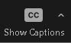 | See how to turn Zoom captions off and on.
You cannot view a poster session | Due to low participation in prior years, poster sessions are available in-person only.
You cannot find a specific presenter | Poster sessions are available in-person only, which means poster presenters are listed in the final print program and the meeting app but not on the virtual components website.
You need to reach the meeting ombuds | Email: saaombuds@gmail.com  Phone: +1(949) 293-7515  The ombuds can be contacted up to 30 days after the close of the meeting.
You need to report a violation of the Meeting Safety Policy | Fill out a report and email it to SAA President (president@saa.org) and/or Executive Director (saaannualmeeting@gmail.com)

Attendees may also find this additional information helpful
You are interested in a presenter’s slide deck or other materials | Contact the presenter to request their paper, presentation, or materials
You need a Constancia or a certificate of participation | Email your name, session title(s), and role(s) to office_manager@saa.org
You want to view a recording or see the presentation on demand | Due to the low number of views of the sessions recorded at the 2021 virtual meeting and to keep meeting registration rate increases as low as possible, we will not be recording sessions. Virtual attendees can join the meeting live at the time published in the final program in US Central Time.  You may wish to contact the presenter to request their paper, presentation, or materials

